Testing
- Server crash on new profile creation
- no message on searching at page http://alchemy-002.herokuapp.com/security_type/4 if no result found
- on hover unreadable text 3rd row

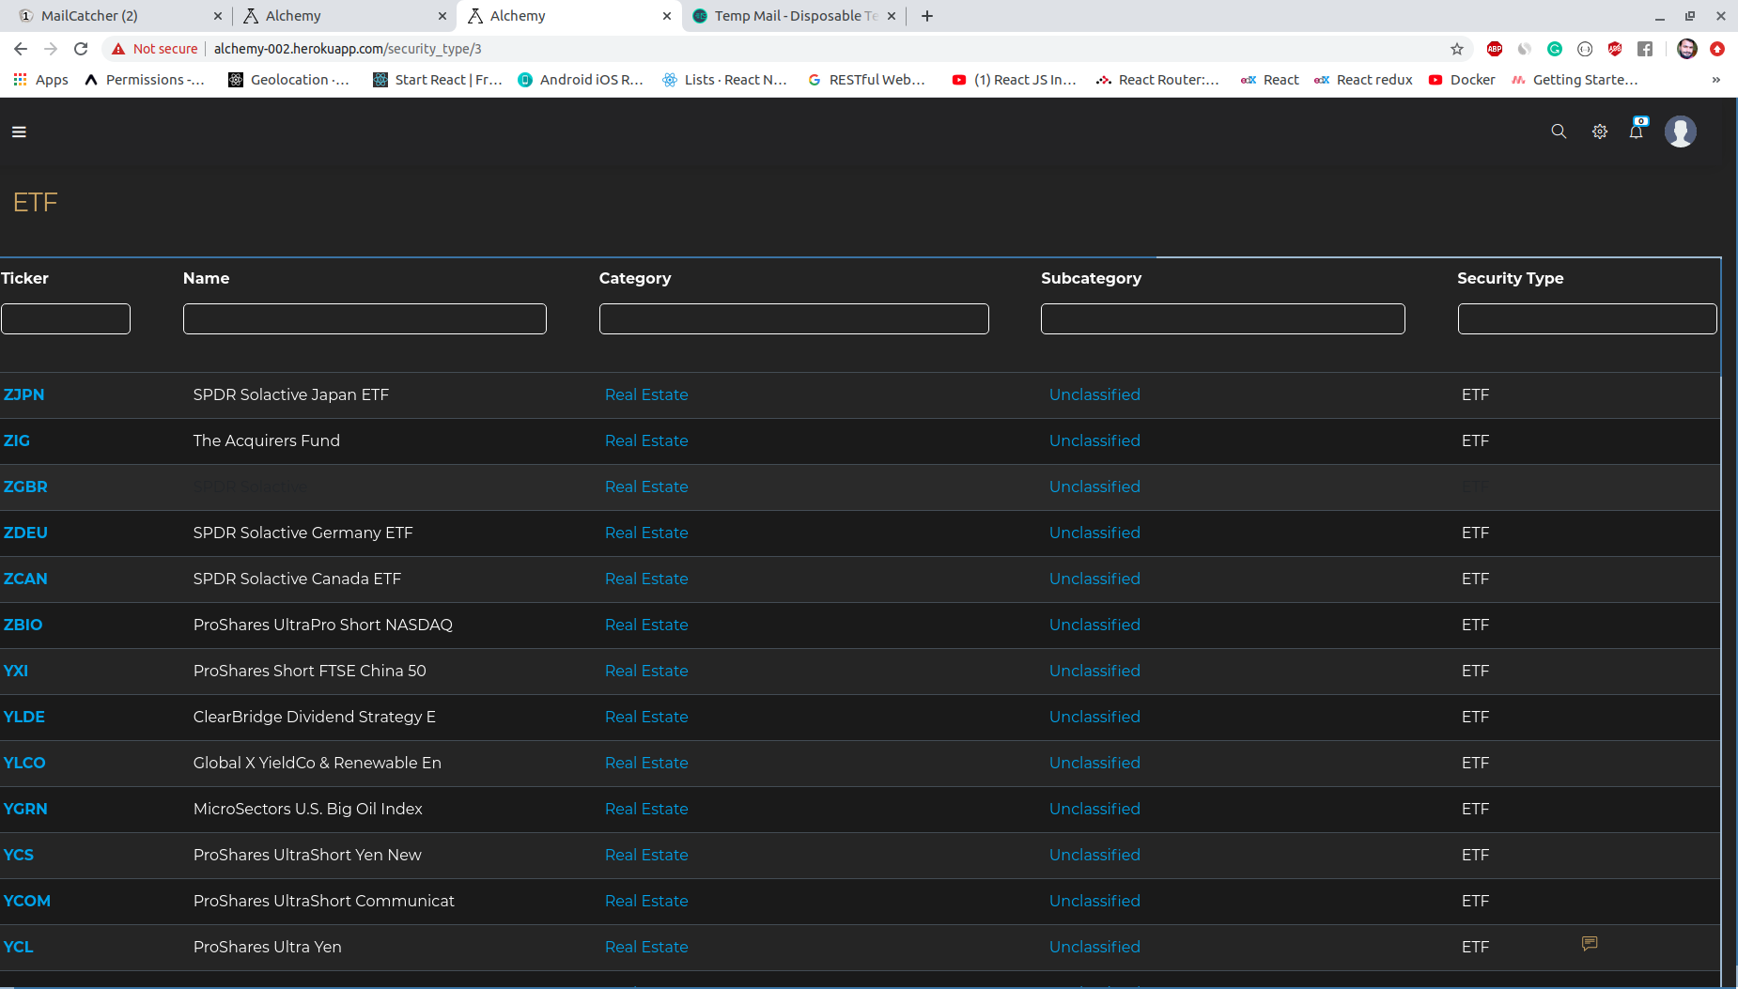
- from http://alchemy-002.herokuapp.com/sub_categories/235 to security show page is not opened error
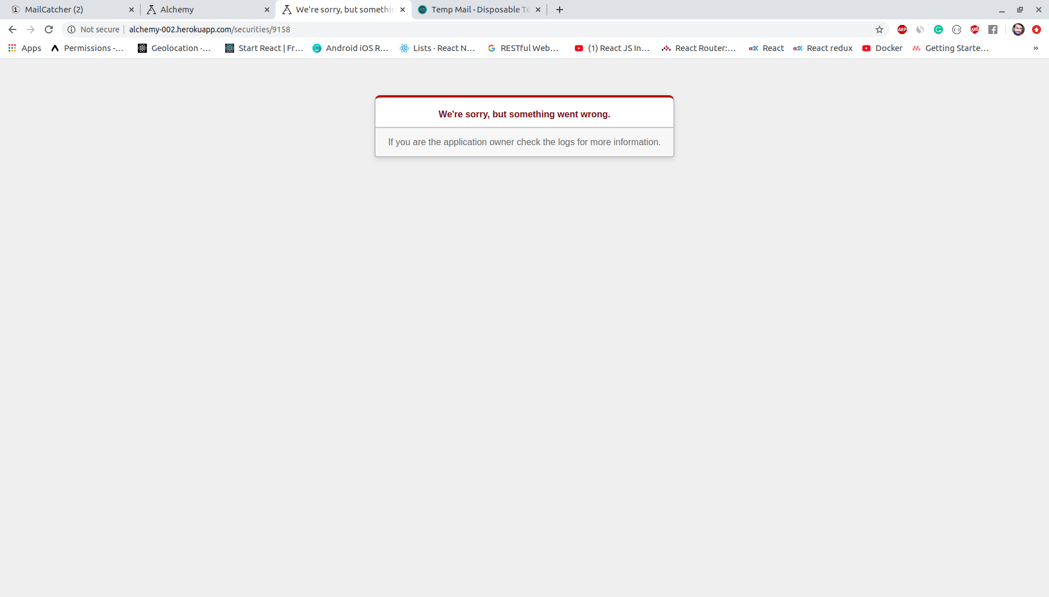
- description empty unless it is existing for watchlist on watchlist index page
- can not add trade_journal_entries to journal error used both id and name in trade journal field
- feedback status can be changed able by the default user
- from watchlist index page watchlist open , edit, share, delete is not working

